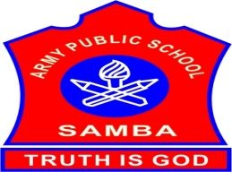
ARMY PUBLIC SCHOOL SAMBA
WEEKLY REPORT
AUGUST 28,2023- SEPTEMBER 01,2023

SCHOOL EVENTS

INTER HOUSE BADMINTON MATCH FOR (BOYS AND GIRLS)CLASSES III-V (AUGUST 28,2023)
The Inter-House Badminton match for the students of classes III-V (Boys and Girls) was organized on August 28,2023 in the MP Hall of APS Samba.The students from all the four houses took part in the competition with high sportsman spirit.
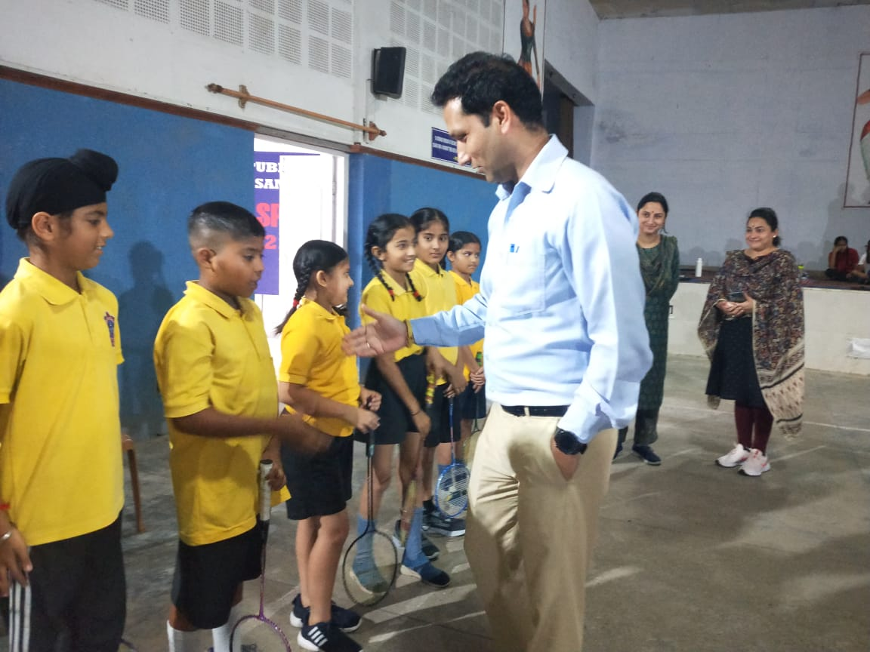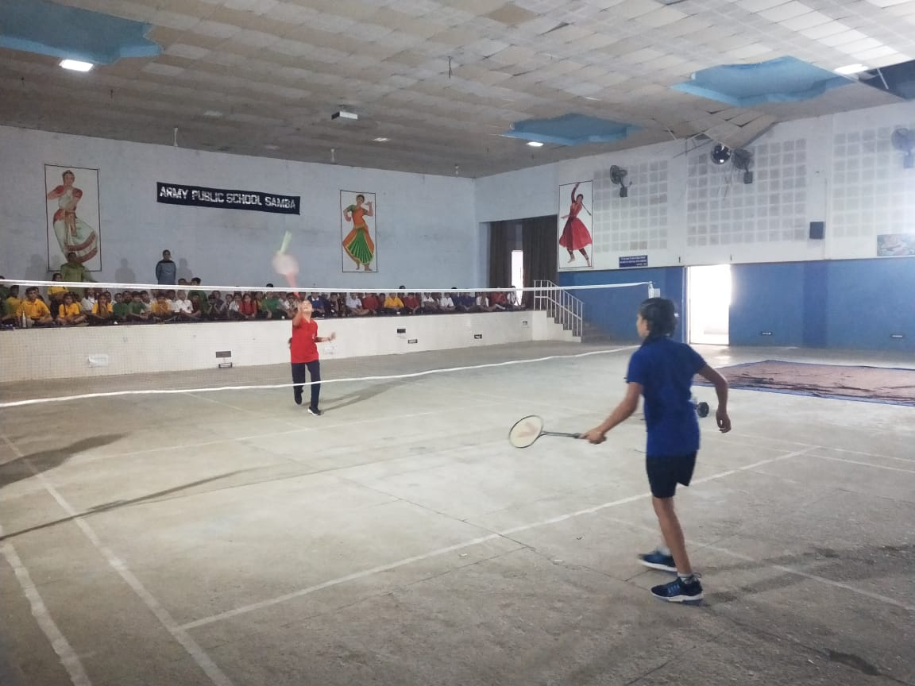
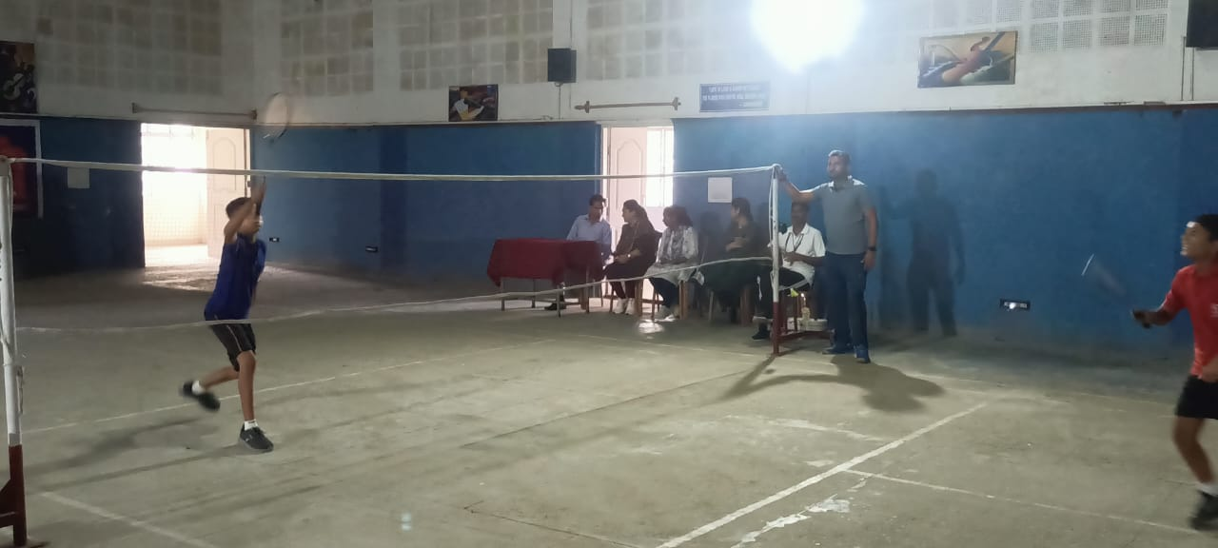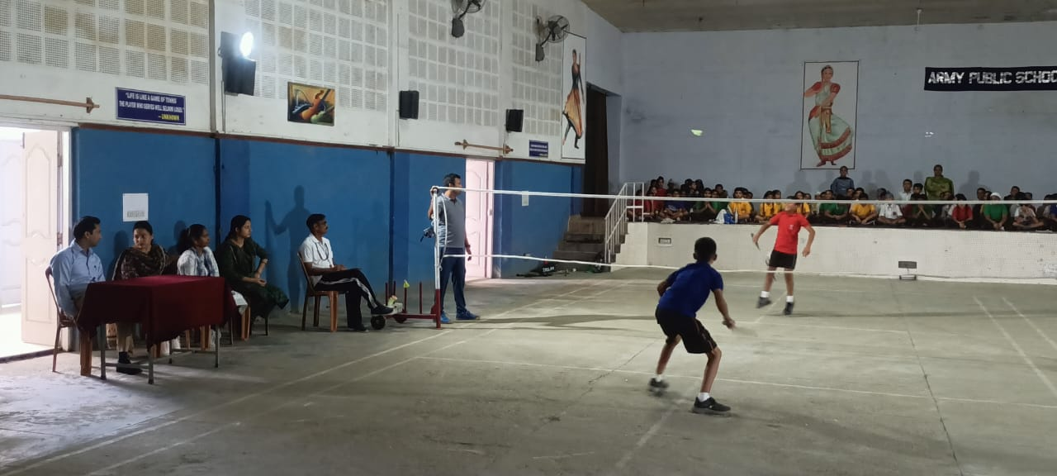
INTER HOUSE SOLO SINGING COMPETITION (IX-XII) (AUGUST 29,2023)
An Inter House Solo Singing Competition was organized for the students of classes IX-XII on the occasion of Rakshabandhan on August 29,2023 on the theme “Bond of love between brother and sister”.There were two participants from each House. The competitors sang a variety of songs.They came up with such melodious voices which in the run attracted the audience . All our young soloists who took part in the competition and made the competition a great success. The winners were felicitated with trophies by the Principal. The result of the competition is as follows:
First position: Manogya Sharma and Nirbhay Singh IX –Teresa House
Second Position: Gagan XII - Gandhi House
Third Position: Arinjay Singh IX – Sarojini House

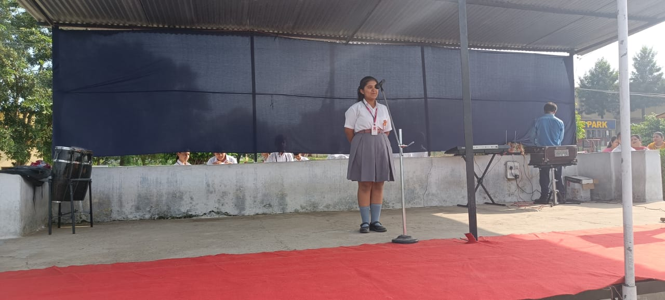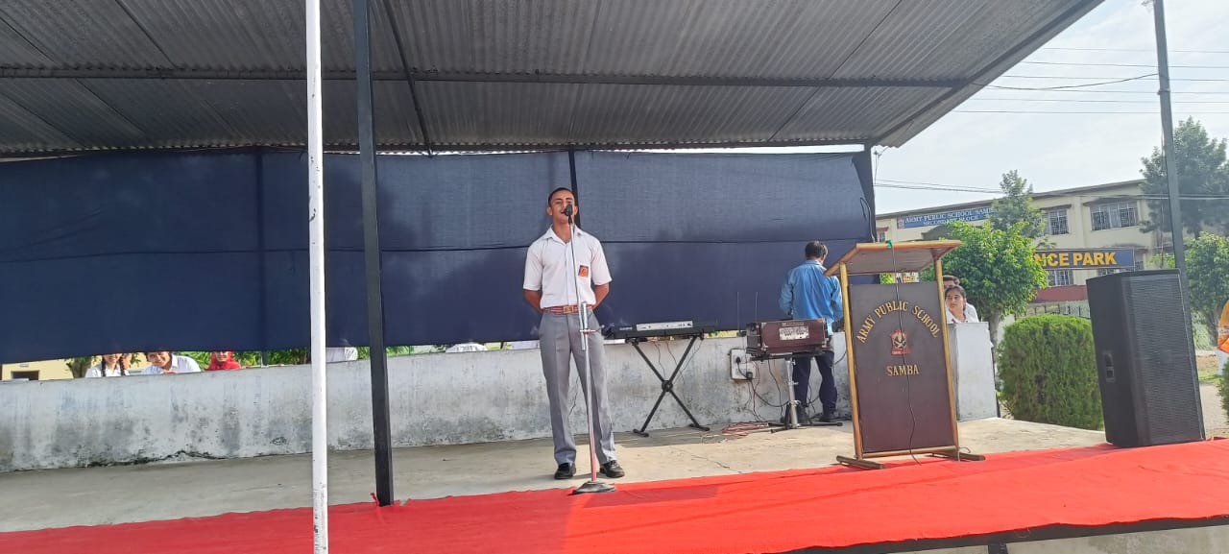

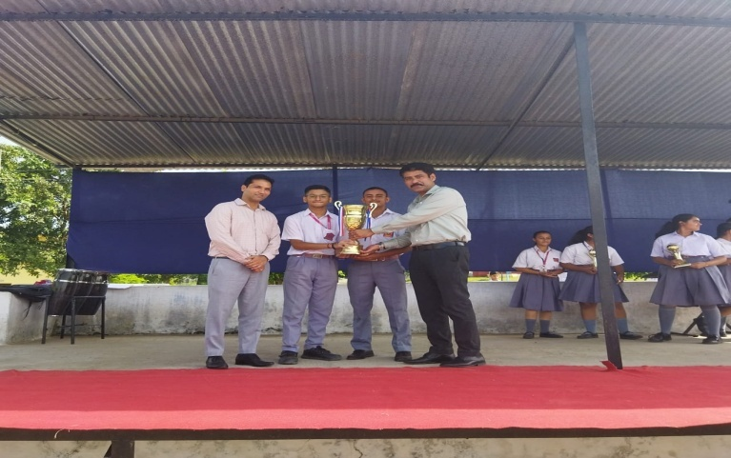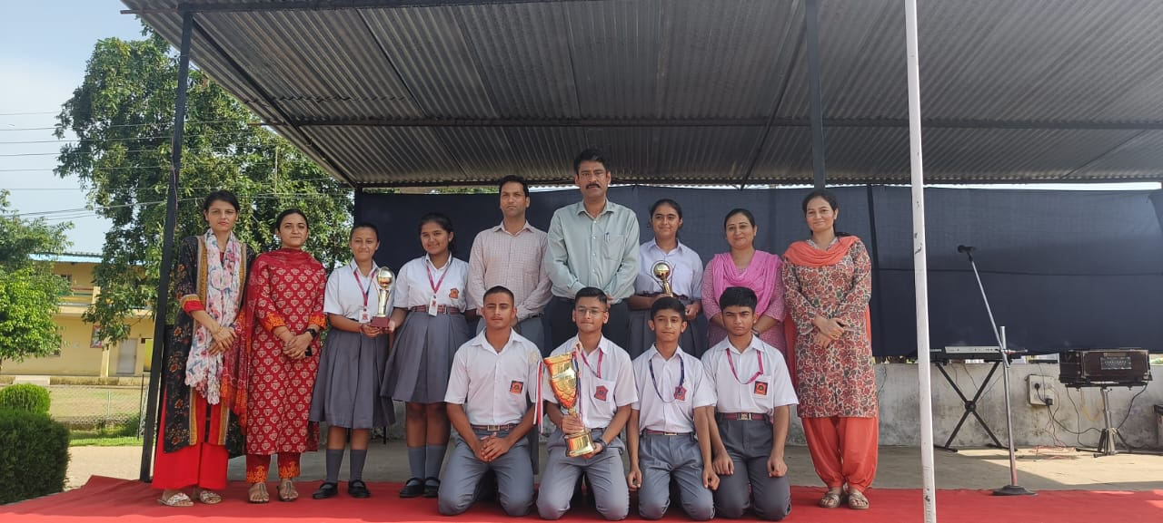
ART OF LIVING SESSIONS FOR STUDENTS OF CLASSES VIII-XII (AUGUST 25,2023)
To enhance intuition,confidence and to boost creativity and intelligence amongst students,the teachers and volunteers from ‘Art of Living’ conducted sessions for the students of classes VIII-XII at APS Samba on August 25, 2023.Meaning of proactive approach to life and significance of Meditation was also explained to them in these sessions.Students actively participated in the sessions.Total 26 students from the school gave willingness to attend the sessions in future and deposited the fee.

NIAS-ALC OFFLINE SESSION (AUGUST 23,2023)
Offline session of NIAS- ALC was conducted on August 23,2023.The topic of discussion for the class was- “ Creating stories using scratch 2.0/3.0. Class was fully interactive and students took part in the discussion with great interest.
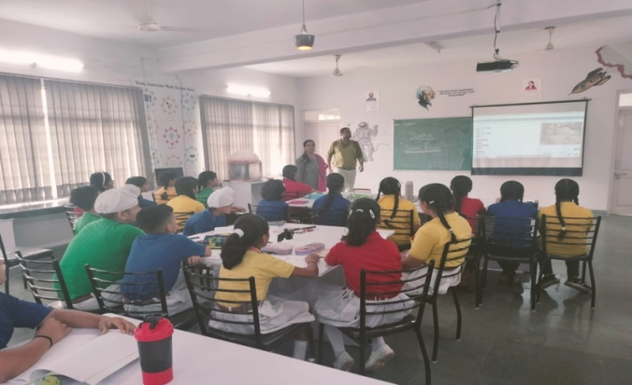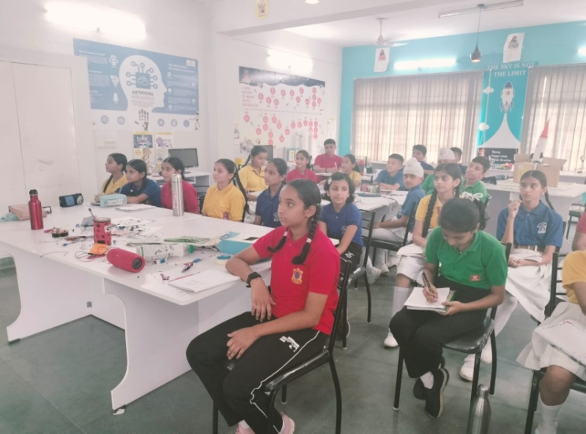
ARYABHATTA GANIT CHALLENGE 2023-REGISTRATION (AUGUST 21-24,2023)
To enhance the mathematical abilities of the students,the registration process for ‘Aryabhata Ganit Challenge’ was held at APS Samba from August 21-24,2023.The students from classes VIII-XII registered themselves for the same.
RAKHI CELEBRATION (AUGUST 25,2023)
To mark the celebration of Raksha bandhan, various competitions were organized for the students of classes I-V on August 25,2023 at APS Samba:
CLASS I & II – English Poem Recitation CLASS III- Rakhi Making
CLASS IV-Book Mark Making CLASS V- Pen Holder Making
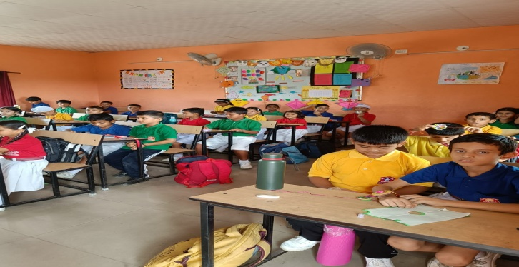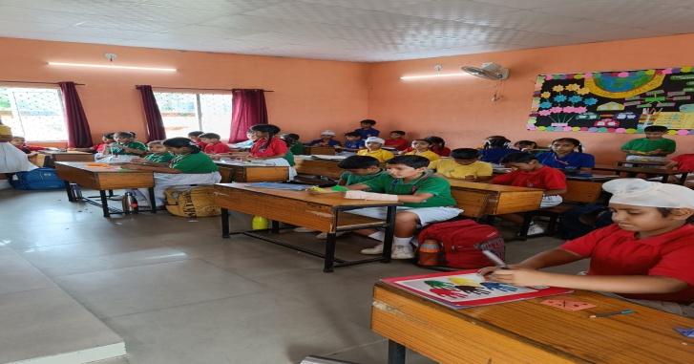

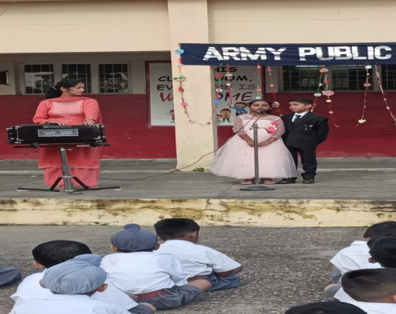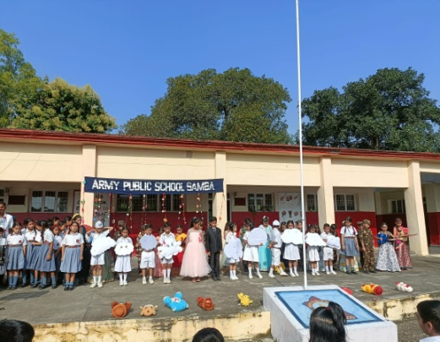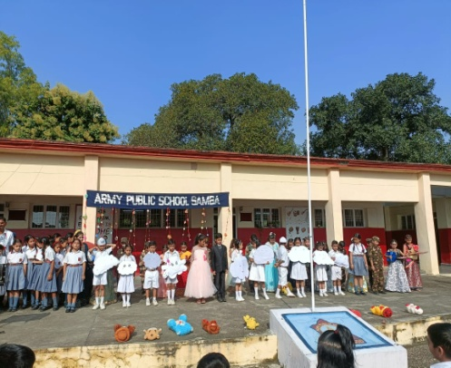

WORKSHOP ON POSITIVE REINFORCEMENT ( AUGUST 26,2023)
A workshop on ‘Positive Reinforcement’ for the Primary Teachers was conducted by Ms Avneet Kour, PRT on August 26,2023 at APS Samba.

THANK YOU

